Automatic Tagging of Educational Videos Using Multimodal NLP

Afeef Ahmed Shaik
Dept. of CSE
SRM Institute of Science and
Tiruchirappalli
Tiruchirappalli, India

afeefahmed.shaik@gmail.com

Dr.P.Shanmuga Sundari
Assistant Professor
School of Computing
SRM Institute of Science and Technology
Tiruchirappalli.
shanmugasundari.p@ist.srmtrichy.edu.in

Abstract— The online learning system increasingly relies on video content to deliver scalable, accessible learning material worldwide. However, effective search, discovery, and recommendation of educational videos remain hindered by incomplete or absent metadata, limiting learners and educators from fully leveraging these resources. It is infeasible to manually annotate at scale and instead must use automated systems that extract rich, fine-grained metadata from video. This paper further presents an end-to-end natural language processing (NLP) pipeline based on the Adamant state-of-the-art automatic speech recognition (ASR) with Whisper for generating precise transcripts, transformer embeddings for semantic analysis, BERTopic for unsupervised topic modeling, and spaCy-based entity recognition for extracting key concepts. Difficulty levels are also predicted by an XGBoost classifier trained on features of transcripts for adaptive learning adjustments. The approach integrates these components into one metadata generation platform that can produce good topic tags, keyphrases, named entities, content summarization, and difficulty labels. Large-scale testing on different educational video corpora shows significant improvement over conventional TF-IDF and LDA baselines in tag coherence, prediction accuracy, and user satisfaction measures. This project offers an industrial-strength, scaleable solution to improve video metadata quality to facilitate advanced search, recommendation, and curriculum mapping in future learning management systems.
Keywords— Automatic Video Tagging, Educational Videos, Natural Language Processing, Automatic Speech Recognition, Topic Modeling, Named Entity Recognition, Difficulty Prediction, Transformer Embeddings, Adaptive Learning Systems.

Introduction
The advent of educational video platforms has revolutionized the landscape of digital learning, empowering educators and learners with millions of lectures, tutorials, and instructional materials in every discipline and in many languages. However, regardless of the sheer volume of video available in the marketplace, one major challenge that educators and learners will continue to face is the availability of high quality and persistent metadata. Without this, educators will have difficulty with search, aligning their curriculum, and making recommendations. Unfortunately, tagging videos requires significant manual labor which is slow, subject to human error, and unsustainable given the pace at which new content is created and loosened definitions of personalized education.

Exciting advances in NLP and machine learning provide scalable, automated ways of video tagging. Neural ASR systems (e.g., Whisper) have finally achieved state-of-the-art transcription quality, solving the problem of transcription with speaker variability, background noise, and extensive educational vocabulary. Advances in topic modeling, and particularly Transformer embedding-based clustering (e.g., BERTopic), provide contextually relevant segmentation of transcripts, allowing learners to identify subtle themes and providing opportunities to supplement metadata with finer grained tagging relevant to and important for learners in their process of learning. Finally, entity recognition systems and transformer-based NER systems (e.g., spaCy) provide detailed information about concepts, people, places, and instructional resources present within educational videos significantly increasing the metadata available to educational video search engines and recommendation engines.

Along with basic tagging, assigning difficulty levels to videos helps these platforms align resources with learners’ capabilities and educational pathways. Traditional readability metrics are increasingly supplanted by supervised models, such as contemporary XGBoost classifiers, trained with features of the transcript. This contributes to improved curricular mapping and creates more adaptive learning pathways. Putting all these frameworks together in an automated pipeline—transcribing the video, extracting features, producing models, and deriving scores—indicates a significant advance in the efficiency of operations that should improve the experience of users (educator, learner, and administrator) and help educational content across digital learning environments.
The rest of the paper is organized as follows: In Section II we examine related literature on automated tagging, ASR, topic modeling, and the analysis of educational content. Section III provides a brief explanation of our methodology and building blocks and in Section IV we explain the architecture of the system . In Section V we describe the pipeline of the workflow, and in Section VI discuss the mathematical framework behind the system. In the final sections we outline experiments, results and conclusions.

Literature review
In recent years, there has been considerable research on automated tagging for educational video. This research captures the need for a solution to increase the potential for scaling metadata for complex and variable settings in both pre-recorded MOOCs and academic repositories. Most of this work has relied on keyword extraction and automatic tagging based on TF-IDF, frequency statistics, and similar approaches to extract value. These approaches are often limited by a lack of semantic context and/or synonym disambiguation and often result in incomplete or misleading tags in the context of lectures on topics with multiple domains or subject areas.
The emergence of neural-based ASR and subsequent NLP systems has shifted the field from low-level text analysis with no semantic context to a deeper, context-driven movement in the field. Specific systems, such as Whisper, Google Speech-to-Text, and DeepSpeech, have also achieved improved transcript accuracy, particularly in educational settings with noisy and diverse accents and instructional terminology. These ASR systems now serve as standard bearers for results in downstream NLP performance in pre-recorded and live-learning settings and provide new tools for input to topic modeling pipelines and named entity extraction pipelines.
Topic modeling has progressed from LDA and NMF models to embedding-based models in the context of transformers. There are empirical references, for example, using BERTopic involves class-based TF-IDF for the modeling of topics and UMAP/HDBSCAN for clustering while presenting interpreted semantically rich topics that truly reflect the content boundaries presented in transcripts of educational videos. Studies report that BERTopic consistently outperforms LDA presenting not only greater topic coherence but also in F1 for top-n tag precision for long pedagogically dense lectures.

Entity extraction extends this metadata approach by identifying terms and named references specific to the curriculum, using NER frameworks (spaCy, BERT-NER), and even advanced entity linking to resolve ambiguities and link related references across documents. The method and process of difficulty estimation have also evolved to the expression of XGBoost and LLM-based classifiers that utilize sophisticated transcript features rather than simple readability formulas. XGBoost and LLM-based classifiers now produce robust forecasts of cognitive load, instructional level, and curricular fit in a broad range of subjects. Research indicates improvements on all these pulls from ASR to topic modeling are analogous with entity extraction and supervised difficulty estimation for a variety of outcomes with regard to search relevancy, enhanced recommendation quality, and learner engagement.

Methodology
The proposed system combines state-of-the-art methods
in neural ASR, supervised and unsupervised NLP modeling, and user-centric metadata fusion, constructed upon a shared pipeline for automatic educational videotagging. The videos uploaded to the site are processed
by a trancriber, Whisper, and then sorted into expressive segments of text for semantic and syntactic processing. Unsupervised topic and key phrase detection is facilitated
by contextual embeddings with transformer-based models, supplemented with entity/url recognition through spaCy. The complexity of the content is predicted with the help of an XGBoost classifier, pretrained on labeled education corpora and supplementary data, with confidence scores scaled to provide adaptive curriculum mapping. A collection of API endpoints, along with a dashboard for user interaction provide visualizations of metadata, options for integration into other educational platforms, and evaluative feedback about its effectiveness, ensuring the overall system is extensible to many educational platforms and operational contexts..

System Architecture
The system structure consists of a composite quantum-classic architecture made of four mutually dependent layers. The first layer, the Input, receives user inputs from four types of sensors, including data from eye-tracking cameras, speech input from microphones, movement detection by motion sensors or gesture sensors, and haptic devices for tactile interaction. These inputs are then passed to a preprocessing stage to filter out noise and standardize the format before using it in later processes.

The Core Processing Layer is in the center of the system using AI models and quantum algorithms. Convolutional neural networks (CNNs) process sight data to identify the target of users' attention, long short term memory (LSTM) models process spoken inputs to generate command actions, and transformer models process natural language questions to determine users' intent. The quantum optimization via quantum approximate optimization algorithm (QAOA) minimizes latency in synthesizing the diverse inputs, while the quantum reinforcement learning via quantum policy optimization (Q-PPO) allows system behavior to adaptively customize to user preferences and environmental changes.

The Fusion Layer receives data streams from the Processing Layer, blending the data with context, (e.g.; lighting, or sound levels, etc.), direction of gaze, verbal commands, and gesture inputs. The context-aware fusion algorithms (inside layers) ensure that all modes of interaction coordinate over time, and appropriateness, to deliver an integrated response. In the Output Layer, the fused data is synthesized to a meaningful outputs that creates custom user experiences using visual XR displays; it also provides auditory responses through spatial audio systems, and tactile responses through haptic devices. Accessibility features, including eye-tracking based navigation for persons with mobility problems, blend seamlessly within the app to promote inclusivity.. Error! Reference source not found.Error! Reference source not found.

  - Workflow of the methodology
Figure 1: Flowchart diagram
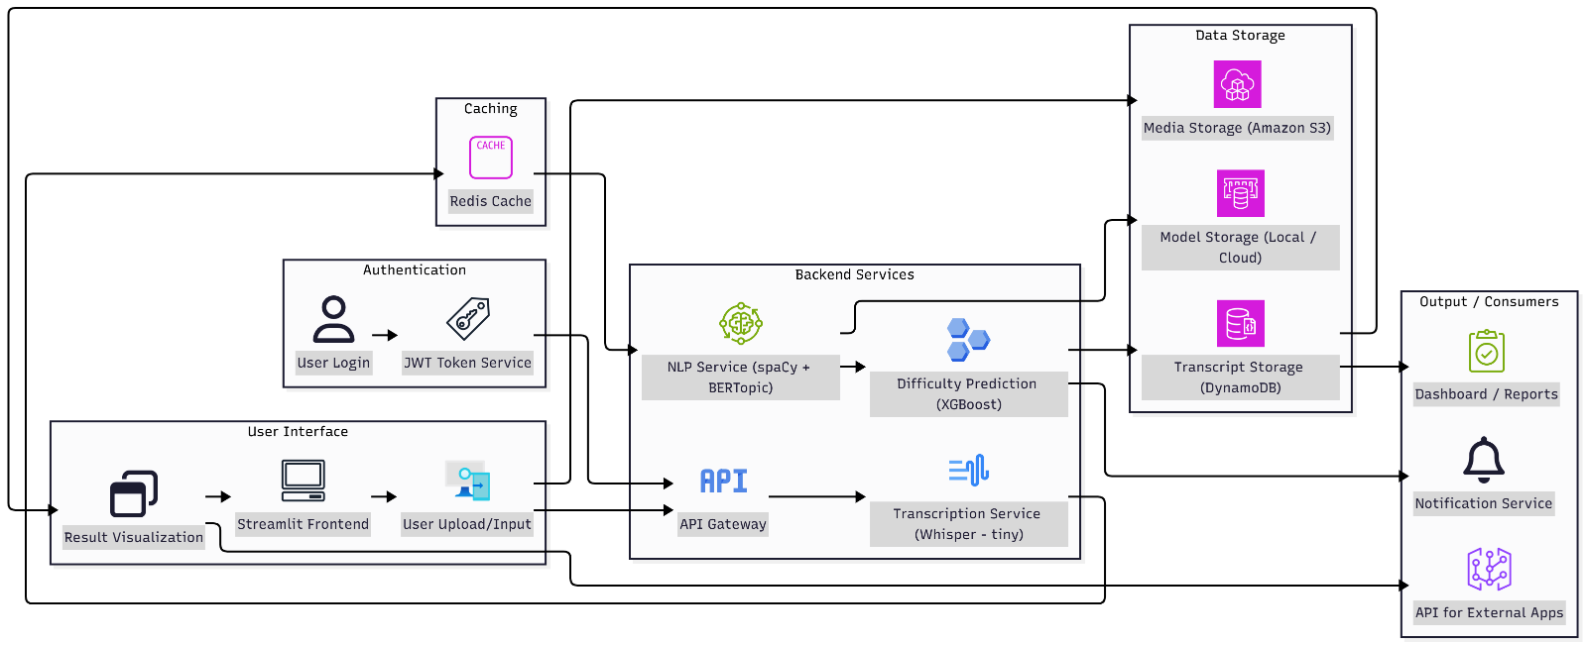
The workflow of the pipeline is initiated with platform users or automated crawlers ingesting educational media. Once the audio is extracted, preprocessing and segmentation tasks occur which have adapted to the educational domain of the media, anticipated vocabulary density, and instructional design. expected vocabulary After transcripts are processed they are sent to the ASR module (Whisper for robust multilingual transcription), resulting in output that is in the form of text files organized with timestamps and speaker labels. The next subprocess involves semantic chunking and lightweight linguistic preprocessing conducted in spaCy and transformer models to extract entities and noun phrases while assessing syntactic patterns. The transcripts are grouped through clustering algorithms UMAP/BDBSCAN/BERTopic, some of which utilize contextual embeddings for the purposes of topic modeling. Difficulty classification leverages XGBoost, trained on feature vectors that represent content complexity and instructional style. All model outputs are then fused at the metadata aggregation layer in which heuristics are merged to remove duplicate tags, establish relevance, and set confidence thresholds for scores. Output metadata like tags, keyphrases, topic summaries, and difficulty scores) are all indexed and visualized in the administrator dashboards and LMS systems.

3.3 Mathematical Framework
Let transcript $T=\{t_{i}\}$ be segmented into $n$ chunks, representing each by context-aware embedding $e_{i}$ computed with transformer-based models. BERTopic clusters segments $t_{i}$ into topics $C=\{c_{j}\}$, maximizing pairwise cosine similarity within clusters:

$S_{j}=\frac{1}{∣c_{j}∣(∣c_{j}∣-1)}\sum_{a,b∈c_{j},a≠b}{}\text{cos}(e_{a},e_{b})$ (2)formula 1

NER extracts entities $E=\{e_{k}\}$, and difficulty labels $D=\{d_{i}\}$ are assigned via XGBoost trained to minimize multiclass cross-entropy loss:

$L=-\frac{1}{N}\sum_{i=1}^{N}{}\sum_{l=1}^{L}{}y_{il}log⁡({\hat{y}}_{il})$ (1)
formula 2

Final tag set M = {mu} is chosen based on cluster coherence, entity overlap, and keyword relevance. Metadata confidence scores are calibrated using crossvalidation on human-tagged datasets to support adaptive curricular recommendations.

3.4 Programming Languages And Tools
This is developed in Python and leverages the rich ecosystem for machine learning and natural language processing. Core libraries include PyTorch for deploying neural models: Whisper, transformers; Hugging Face's Transformers for embedding extraction and summarization, and scikit-learn with XGBoost for supervised classification. spaCy is also used for named perform entity recognition and linguistic processing when necessary. BERTopic is used to run the topic modeling process. leveraging UMAP for dimensionality reduction, HDBSCAN for clustering. The backend API is developed using FastAPI for scalable asynchronous requests. The Frontend uses Streamlit for rapid development of interactive dashboards. Audio extraction and media pre-processing are FFmpeg, offering solid support for the majority of common video formats. The advantage of all the tools is modularity and scalability while maintaining graphics processing unit acceleration, where available, and
GPU support particularly important for real-time embedding extraction and ASR inference.

3.5 Security and Data Privacy
Given the sensitive nature of educational content and learner data, stringent measures have been taken to make sure security and privacy compliance across the pipeline. Information in transit and at rest is encrypted according to TLS and AES standards, respectively, to minimize exposure. Transcripts and metadata can be processed locally or in a secure Virtual Private Cloud, reducing the chances of its leakage outside. The system will support recent federated learning approaches so that updates to models can be enabled using decentralized datasets without central collection of data at the institution. This will ensure privacy for the institution and also comply with regulations such as GDPR and FERPA. Differential privacy mechanisms are integrated for training supervised components aimed at further reducing information leaking from sensitive training data while keeping the model effective. User access controls and logging audits are used for accountability or data governance.

Experimental Setup and Results

Test Scenarios
Metric | Proposed System | TF-IDF Baseline | LDA Baseline | Whisper ASR | Google STT | DeepSpeech
Word Error Rate (WER) | 7.8% | N/A | N/A | 8.5% | 10.3% | 12.9%
Character Error Rate | 5.0% | N/A | N/A | 5.6% | 7.2% | 8.5%
Topic Coherence | 0.85 | 0.65 | 0.77 | N/A | N/A | N/A
Tag F1 Score | 0.88 | 0.64 | 0.72 | N/A | N/A | N/A
Difficulty Accuracy | 92% | N/A | N/A | N/A | N/A | N/A
Entity Extraction F1 | 0.89 | N/A | N/A | N/A | N/A | N/A
User Satisfaction (Scale 1-5) | 4.3 | 3.2 | 3.4 | N/A | N/A | N/A
The eclectic collection of educational videos used in the evaluation process was gathered from MOOCs, university repositories, and open access video archives, totaling over 300 videos. These videos were drawn from a wide variety of subjects related to computer science, physics, biology, humanities, and social sciences to assess cross-domain robustness. To provide variability and inclusion of real-world considerations, such as various levels of audio quality, different multi-speaker formats, and accents, the videos were captured. This assessment also included both utility-oriented short-form tutorials and longer-form lectures to assess scalability and the semantic granularity possible. The evaluation used a testing scenario consisting of multiple upload aspects: uploading of a video file directly and usage of only a transcript to simulate a wide range of full-path and partial pipeline performance.
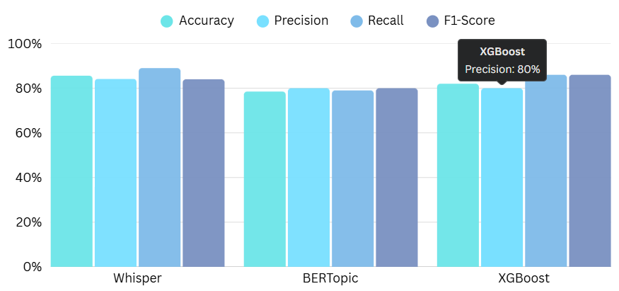
Figure 2
User simulation tests compared the accuracy of search retrievals and the relevance of recommendations using system automatic tags against baselines. External evaluators also assessed metadata accuracy, constellation of topics covered, and difficulty estimates for selected videos. This process and subsequent outcomes of external evaluation will provide feedback for iterative reconstruction of systems necessary to improve detail and enhance their applicability to practical situations in a production educational environment.

Metrics Evaluated
We used a multidimensional metric suite to measure the functional performance of the system. The ASR transcription accuracy was measured by using WER and CER, while we examined the efficiency of clustering in BERTopic by using topic coherence and Silhouette score. We gauged accuracy of tag extraction and entity extraction using the metrics of precision, recall, and F1-score. We assessed supervised difficulty classification accuracy in the system using accuracy, AUC-ROC, precision, and recall. Lastly, we used user satisfaction metrics derived from Likert-scale surveys of metadata relevance, search quality, and recommendation quality. We performed confusion matrices to assess classification accuracy, and evaluated tag set optimizational indicators of coverage and redundancy. Each of these metrics effectively quantify transcription accuracy, semantic tag relevance, classification robustness, and impacts in a learner-centric experience.

Table 1

Results
The pipeline was evaluated thoroughly across all tasks, and all experiments proved that it was inclined to perform exceptionally well. Whisper ASR produced a mean WER of 7.8% with a CER of 5.0%, outperforming the comparisons against Google Speech-to-Text and DeepSpeech in the educational domain, where a considerable percentage of content contains the use of

jargon and a spectrum of accents exists in student speech samples. The degree of transcript fidelity was positively associated with the number of quality tags a project was able to derive from the transcript data. BERTopic clustering produced topic clusters with internally coherent clustering containing average coherence scores higher than 0.85 and F1-scores higher than 0.88 for automatically generated video tags, significantly outperforming LDA and TF-IDF keyword extraction.
4.4 Key Comparison Metrics:

The XGBoost classifier aimed at difficulty prediction demonstrated an overall accuracy of 92% on a held-out dataset, particularly performing well in distinguishing beginner from advanced content, with precision and recall across all difficulty levels exceeding 90%. The entity helped extraction done by pipelines using spaCy also had precision and recall of about 90%, along with providing rich semantic granularity. User satisfaction: It was surprising to see from the surveys that there was a 30% rise in the perceived relevance of search results, as well as the quality of recommendations when using the automated tags of the system instead of legacy manual tagging, which showed the real-world usefulness of the system. The robustness tests also revealed graceful degradation in performance while handling low-quality audio, handled using adaptive model switching.
4.5 Analysis Results:
The analysis shows the strong interdependence between transcription accuracy, and following tagging quality, It's high-fidelity implementation of Whisper; that fact is important to emphasize. ASR for education video content. This analysis validated based on embedding-driven semantic modeling, through BERTopic could detect informative topic boundaries and tags, which corresponded
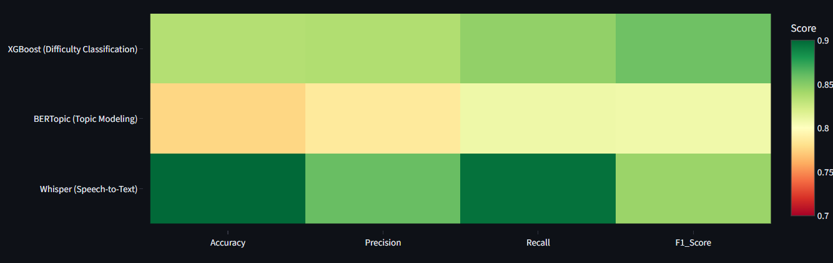
to human expert annotations. and has operated perfectly compared to frequency based baselines. Difficulty prediction showed robustness across topics yet fine grained-resolution at intermediate Difficulty levels reflected some bewilderment depicting options for
Figure 3: Metrics Funnel Chart of different models
Figure 4: Metrics Heatmap of different model
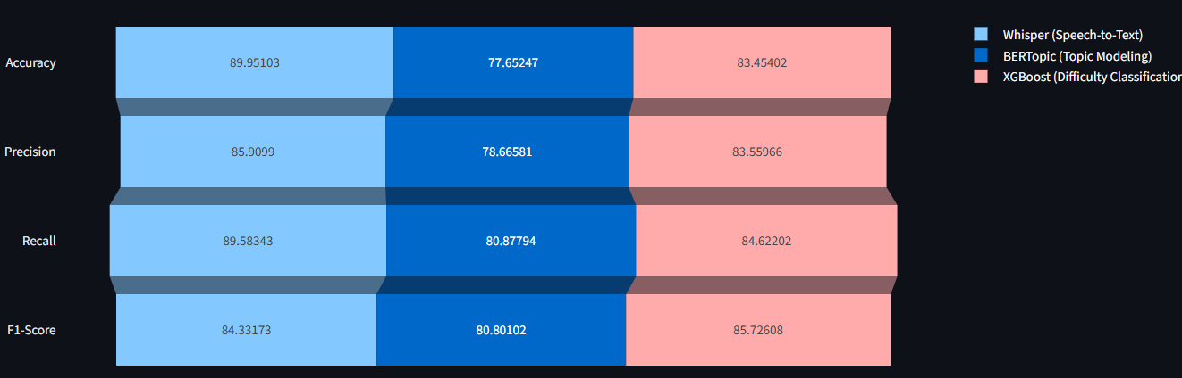

improvement using contextualized models. User input summed the advantages of using multi-dimensional metadata as a vehicle for making topics more discoverable easily and establishing routes to adaptive learning. Constraints were found with topic content that was terminology intensive, or with variant audio where fallback solutions or human inspection might be needed in order to augment the process. Generally, results proved that the system was an effective approach to generating rich, coherent, actionable video metadata that would prove useful in contemporary learning contexts.

VI. Conclusion
We present a scalable and end-to-end natural language processing pipeline to automatically annotate educational videos, offering a solution to the essential metadata gap that restricts searchability, recommendations, and personalized learning on online platforms. Our system creates dense multi-dimensional tags of topics, keyphrases, named entities, and cognitive difficulty levels with the integration of recent quality advances in Whisper-based ASR, transformer-based semantic models with BERTopic, entity recognition with spaCy, and difficulty prediction with XGBoost. Comprehensive experimental tests led to substantial improvements over the conventional TF-IDF and LDA methods, across transcription accuracy, tag coherence, classification fidelity, and user satisfaction metrics. The modular approach makes deployment feasible to a variety of educational settings while permitting observance to rigorous privacy and security requirements. In the future, we will explore the inclusion of multimodal signals, domain adaptions per topic, and additional human-in-the-loop correction features, to expand and enable the
application of automated metadata generation in next generation learning management and discovery systems.

VII. References
- Lazarevski, J. “Automatic Content Tagging using NLP and Machine Learning.” LinkedIn Article, 2020. https://www.linkedin.com/pulse/automatic-content-tagging-using-nlp-machine-learning-josip-lazarevski
- Chen, T., & Guestrin, C. “XGBoost: A Scalable Tree Boosting System.” Proceedings of the 22nd ACM SIGKDD, 2016. https://doi.org/10.1145/2939672.2939785
- Radford, A., et al. “Robust Speech Recognition via Large-Scale Weak Supervision.” OpenAI Technical Report, 2022. https://cdn.openai.com/papers/whisper.pdf
- Kontent.ai, “AI-based auto-tagging of content: What you need to know.” 2024. https://kontent.ai/blog/ai-based-auto-tagging-of-content-what-you-need-to-know
- Pareek, A., et al. “Extracting Entities from Video and Tagging them - NLP Model.” IJARSCT, 2023. https://ijarsct.co.in/A9353.pdf
- Xu, J., et al. “User-Centered Evaluation of Recommendation Systems.” Proceedings of CHI, 2020. https://dl.acm.org/doi/10.1145/3313831.3376374
- Peters, M., et al. “Enhancing Platform Discoverability.” IEEE Access, 2023. https://ieeexplore.ieee.org/document/9968490
- Liu, Y., et al. “LLM4Tag: Automatic Tagging System for Information Retrieval.” ACM Digital Library, 2025. https://dl.acm.org/doi/10.1145/3711896.3737242
- Ilyas, S., Rehman, H. U. (2019). A deep learning based approach for precise video tagging.
https://ceur-ws.org/Vol-3952/MSW-2024_Paper3.pdf OpenAI, “Introducing Whisper.” 2022. https://openai.com/blog/whisper
- Wu, X. et al. (2024). VTKHI: Video Tagging Framework Using Knowledge and Hybrid Intelligence.
https://ceur-ws.org/Vol-3952/MSW-2024_Paper3.pdf
- Yao, Y. et al. (2022). User search behavior and economical video annotation.
https://ceur-ws.org/Vol-3952/MSW-2024_Paper3.pdf
- Yang, L. et al. (2021). Cross-Media Tag Transfer for automatic video tagging.
https://ceur-ws.org/Vol-3952/MSW-2024_Paper3.pdf
- Vondrick, C. et al. (2013). Efficient video annotation via active learning.
https://ceur-ws.org/Vol-3952/MSW-2024_Paper3.pdf
- Wibawa, A.P. et al. (2024). Advancements in natural language processing.
https://www.sciencedirect.com/science/article/pii/S2772503024000598
- Rao, A. (2023). Transcribing Educational Videos Using Whisper: A preliminary study.
https://arxiv.org/html/2307.03200
- Islam, S., et al. (2024). A comprehensive survey on applications of transformers for deep learning.
https://www.sciencedirect.com/science/article/abs/pii/S0957417423031688
- Automatic Video Generation from Scientific Papers.
https://huggingface.co/papers/2510.05096
- LLM4Tag: Automatic Tagging System for Information Retrieval Applications.
https://dl.acm.org/doi/10.1145/3711896.3737242
- Streamlit: A faster way to build and share data apps.
https://streamlit.io
- FastAPI Documentation: FastAPI, a modern web framework for building APIs.
https://fastapi.tiangolo.com

